# **The Tableau HR Scorecard: Measuring Success in Talent Management**

***Introduction:***

In today's competitive business landscape, effective talent management is crucial for organizations to thrive. The ability to attract, develop, and retain top talent can provide a significant competitive advantage. However, measuring the success of talent management initiatives can be challenging. That's where the Tableau HR Scorecard comes in.

In today's dynamic business landscape, human resources (HR) and talent management have emerged as critical components of an organization's success. Companies are increasingly recognizing that their most valuable assets are their employees, and effective talent management strategies can significantly impact overall performance and competitiveness. To thrive in a rapidly evolving market, organizations need to understand how their HR initiatives are driving talent development, engagement, and retention. This is where the Tableau HR Scorecard comes into play.

***Overview:***

The HR Scorecard is a strategic measurement tool that enables organizations to evaluate the effectiveness of their talent management practices. It provides a comprehensive framework for measuring the impact of HR initiatives on business outcomes. By aligning HR metrics with strategic objectives, the HR Scorecard enables organizations to assess their progress and make informed decisions.

**Purpose:**

The Tableau HR Scorecard is a data-driven approach to measuring success in talent management. It leverages advanced analytics and visualization tools provided by Tableau to transform HR data into actionable insights. This project report aims to provide a comprehensive overview of the Tableau HR Scorecard and its application in evaluating and enhancing talent management strategies within organizations.

**Benefits and Applications:**

* This section will explore the benefits of using the Tableau HR Scorecard, including improved decision-making, enhanced employee engagement, and strategic alignment.
* Use data-driven insights to optimize recruitment strategies, employee development programs, and talent retention efforts.
* Continuously track and assess HR performance metrics such as employee turnover rates, time-to-fill job openings, and training program effectiveness.

**ADVANTAGES:**

* A Tableau HR Scorecard enables data-driven decision-making in talent management.
* Offers a comprehensive view of talent management metrics.
* Tableau allows for customization and flexibility in dashboard design.
* Supports ongoing monitoring of HR performance.

**DISADVANTAGES :**

* Data quality and integration can be challenging.
* Setting up and maintaining a Tableau HR Scorecard can be resource-intensive.
* Tableau may have a learning curve for users unfamiliar with the tool.
* Managing data privacy and security is crucial.

**Empathy Map :**

**Problem Definition:**

* + Identify Stakeholders
  + Conduct Interviews and Workshops
  + Analyze and Synthesize Data
  + Define the Problem Statement
  + Integration with Performance Management Systems
  + Automated Talent Analytics Reports

**Design Thinking:**

* + Develop a data-driven talent assessment tool
  + Integrate qualitative feedback
  + Track diversity and inclusion metrics
  + Visualize career development opportunities

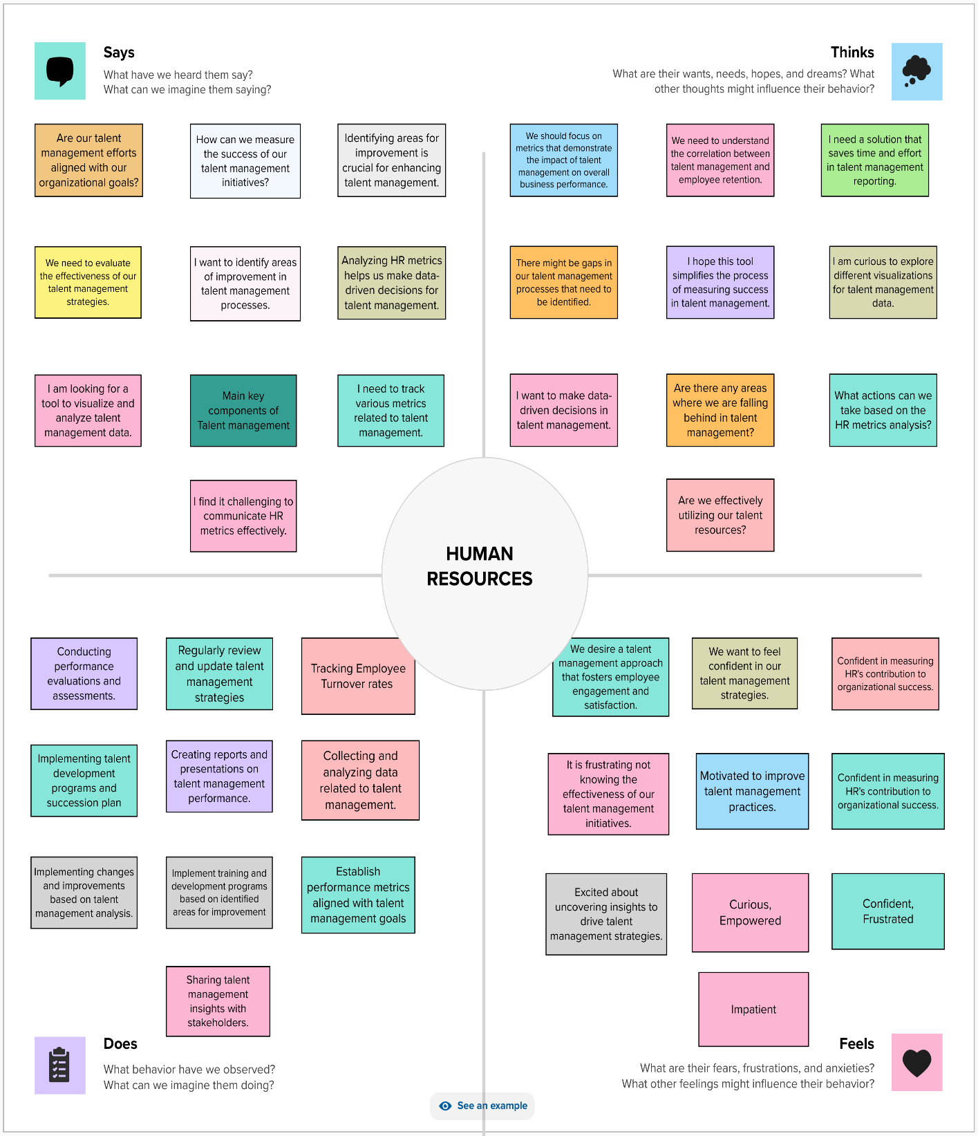

***Ideation & Brainstorming Map:***

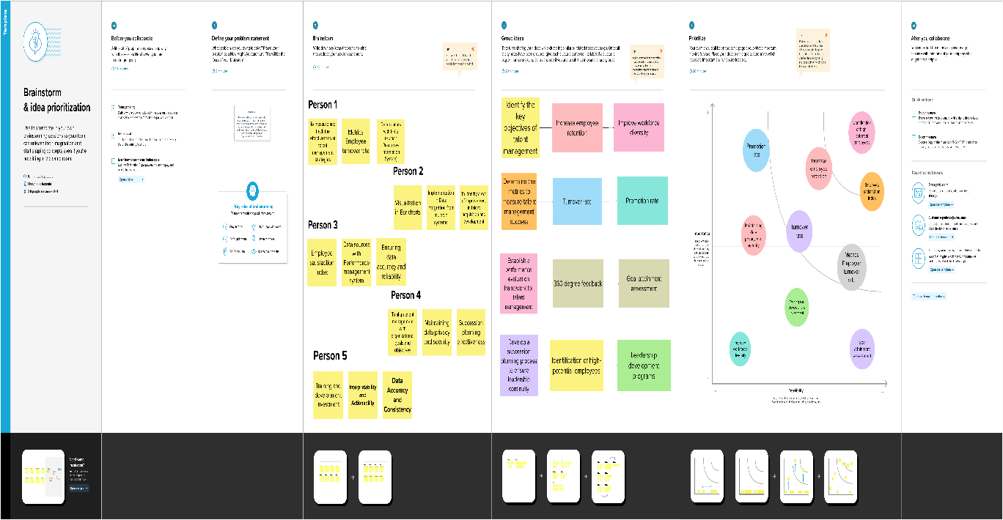

***Problem Definition:***

* + Integrate performance data visualization
  + Incorporate ideation workshops
  + Implement a talent management suggestion box
  + Utilize Tableau HR analytics in talent development

***Design Thinking:***

* + Integration of Key Performance Indicators (KPIs)
  + Real-time Data Visualization
  + Employee Engagement Analysis
  + Interactive Ideation and Brainstorming Map

***FUTURE SCOPE:***

* The future scope of the HR Scorecard lies in its integration with technology and analytics. As HR processes become increasingly automated, organizations can leverage data analytics to gain deeper insights into talent management. By incorporating predictive analytics and machine learning algorithms, the HR Scorecard can provide organizations with more accurate and timely information for decision-making.
* Furthermore, advancements in technology offer opportunities for HR professionals to enhance strategic decision-making in talent management. Tools like Tableau can enable real-time visualization and reporting, facilitating data-driven discussions and decision-making processes. This integration of technology and analytics will undoubtedly shape the future of talent management, allowing organizations to proactively identify and address talent gaps, improve overall performance, and drive business success*.*

***Final Output:***

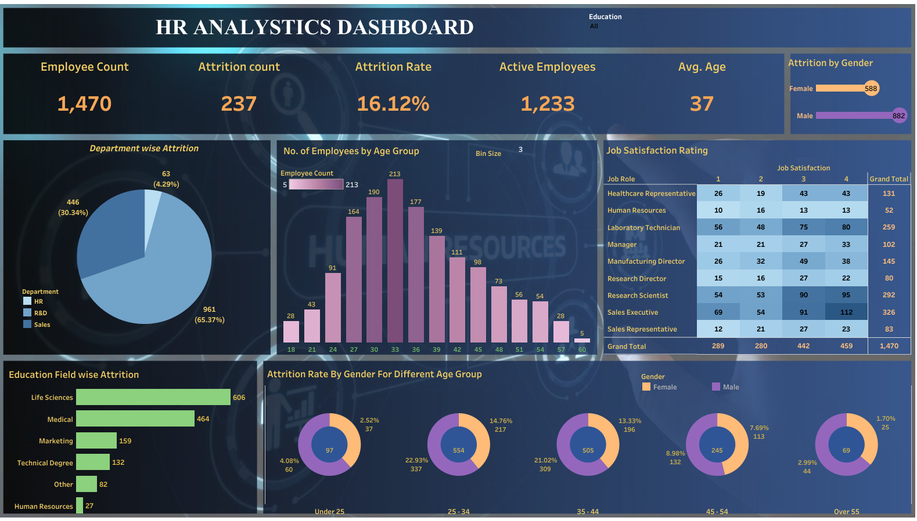

***Conclusion:***

*The Tableau HR Scorecard serves as a valuable tool for measuring and managing success in talent management. By providing a comprehensive framework with diverse metrics, it enables organizations to evaluate their HR practices objectively. The HR Scorecard's future scope lies in its integration with technology and analytics, offering opportunities for HR professionals to enhance strategic decision-making in talent management. As organizations recognize the significance of measuring success in talent management, the HR Scorecard will continue to evolve, providing valuable insights and driving improvements in HR* practices.

***Result:***

The Tableau HR Scorecard is more than just a tool; it's a transformative force that measures and drives success in talent management. It equips organizations with the insights and tools needed to make data-driven decisions, fosters a culture of continuous improvement, and aligns talent management practices with strategic objectives. As organizations embark on this journey toward excellence, the Tableau HR Scorecard remains a beacon that guides them toward a future where talent management is not just a process but a driver of success***.***